BOOK A DOCTOR
ER Diagram Model
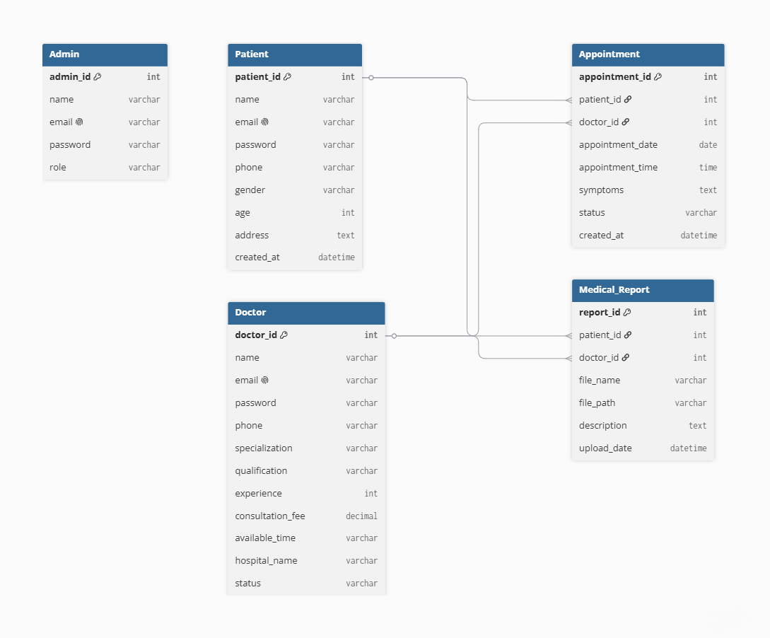
The ER Diagram represents the database structure of the Book a Doctor application. It consists of five main entities: Admin, Patient, Doctor, Appointment, and Medical Report.
The Admin manages doctors and users. The Patient can register, log in, book appointments, and upload medical reports. The Doctor stores professional details and manages patient appointments. The Appointment entity connects patients and doctors by storing appointment date, time, symptoms, and status. The Medical Report entity stores uploaded medical documents related to patients and doctors.
The relationships between these entities ensure efficient appointment management, secure storage of medical records, and smooth communication between patients and doctors, making the system organized and scalable.

